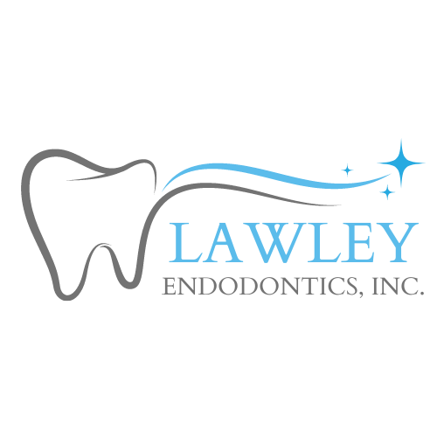

G. Robert Lawley, D.D.S.
Specialist in Endodontics

748 State Route 28 | Milford, Ohio 45150
513-248-0300

NOW THAT YOUR ROOT CANAL IS COMPLETED..................

The root canal system inside your tooth has been cleaned and sealed for you. Because of the pre-existing condition of the tooth and the necessary procedures to treat it, a certain amount of soreness afterwards can be expected. This may not appear until 2 to 3 days after your treatment and may last for 1 to 2 weeks longer.
Please avoid chewing on the treated tooth since tissues heal more quickly when they are not being used. This can be difficult in the mouth, but will reduce soreness and help prevent fracture until the treated tooth is restored.
Anti-Inflammatory pain medications are usually recommended for post- treatment soreness if a person can safely take them. Take 2 to 3 Ibuprofen (Advil, Motrin, etc.) tablets every 6 hours or 1 to 2 extra-strength Aspirin or Tylenol every 6 hours until you experience relief.
If antibiotics have been prescribed, please take them according to the specific directions. For sexually active females taking birth control pills, antibiotics can cause birth control pills to be ineffective. Therefore, an alternative form of birth control should be exercised while on antibiotics and for the rest of that month. If there are any difficulties, please let this office know.
A temporary filling was placed in your tooth after your root canal. You will need to see your family dentist in approximately 2-4 weeks to have the permanent restoration done. Because a tooth that requires root canal treatment has usually had a past history of decay, large fillings, or fracture, a crown of some type is often necessary to protect your tooth. Your family dentist is best qualified to determine how to restore this tooth.
A report of your treatment and a copy of your final x-ray film will be forwarded by us to your family dentist informing him or her that your treatment has been completed.
If any additional questions, concerns, or difficulties arise concerning your treatment, please do not hesitate to contact our office at 513-248-0300. If it is after office hours and you have a true emergency resulting from your treatment, please call 513-373-3099.

Thank you for the opportunity to have participated in your dental care.

